|  |
| --- |
|  |
| Capstone Project Document |

**DANDELION**

Report #6 – Installation Guide

|  |  |  |
| --- | --- | --- |
| **Dandelion** | | |
| **Group Members** | Vũ Công Chính | SE02585 |
| Lưu Ngọc Mạnh | SE02619 |
| Nguyễn Minh Huy | SE02723 |
| Dương Đức Anh | SE02700 |
| Vũ Ngọc Trung | SE02967 |
| Cao Thị Phương Mai | SE02908 |
| **Supervisor** | Mr. Nguyễn Văn Sang | |
| **Project code** | DDL | |

**- Hanoi, 12/2015 -**

# SIGNATURE PAGE

AUTHOR: Dương Đức Anh 08/12/2015

Team member

REVIEWERS: Lưu Ngọc Mạnh 09/12/2015

Project manager

APPROVAL: Nguyễn Văn Sang --/--/--15

Supervisor

Record of change

*A - Added M - Modified D – Deleted

|  |  |  |  |  |  |
| --- | --- | --- | --- | --- | --- |
| Effective Date | Changed Item | A,M,D | Change Description | Reason for Change | Rev. Number |
| 08/Dec/2015 | User installation | A | Add new |  | 1.0 |
|  |  |  |  |  |  |
|  |  |  |  |  |  |
|  |  |  |  |  |  |
|  |  |  |  |  |  |
|  |  |  |  |  |  |
|  |  |  |  |  |  |
|  |  |  |  |  |  |
|  |  |  |  |  |  |
|  |  |  |  |  |  |
|  |  |  |  |  |  |
|  |  |  |  |  |  |
|  |  |  |  |  |  |
|  |  |  |  |  |  |
|  |  |  |  |  |  |
|  |  |  |  |  |  |

Table Contents

SIGNATURE PAGE 1

1 INTRODUCTION 3

1.1 Purpose 3

1.2 Environment 3

2 Installation Guideline 3

2.1 Connecting an ASP.NET MVC Web App with SQL Azure 3

2.1.1 Creating the SQL Azure Database 3

2.1.2 Updating Connection Details in Your Web App 7

2.2 Create & Deploying the Azure Website 8

2.2.1 Create Azure Website 8

2.2.2 Deploying to the Azure Website 9

2.3 Connecting SQL Management Studio to SQL Azure 10

2.3.1 Allowing access to SQL Azure 10

2.3.2 Connecting with SQL Server Management Studio 12

# INTRODUCTION

## Purpose

This document contains guide-lines step by step to deploy DDL App to Azure website and This user's manual has been developed to help users better understand the requirements that may apply to use this website by providing them simple step by step tutorials. This manual is intended to help make website's functions more accessible and their associated requirements more understandable to users.

## Environment

Following are the software required to start the DDL system:

* Operating System: Windows 7, Windows 8, Window 10
* Browsers: Firefox 40, Chrome 44 or higher.
* Database: SQL 2010 or higher
* .NET Framework 4.5

# Installation Guideline

## Connecting an ASP.NET MVC Web App with SQL Azure

### Creating the SQL Azure Database

The first thing to do is creat your sql database on azure:

* Step 1: Go to your azure portal, and click the new button in the bottom left corner

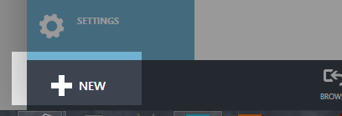

* Step 2: Then choose Data Services >> SQL Database >> Quick Create and fill in the form. My settings were:
  + Database Name: **DDL_CapstoneProject**
  + Server: **New SQL database server**
  + Region: **South East Asia**
  + **Make sure you remember the username and password you choose**
* 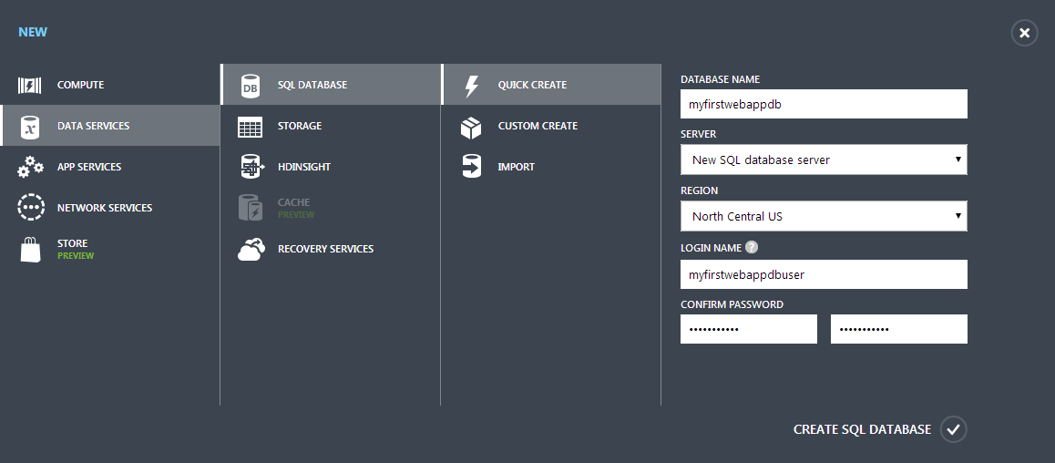Step 3: Press [Create SQL Database] button

After waiting a few seconds your database should be created.

* Step 4: Click SQL Databases on the left column, then select your database in the main pane

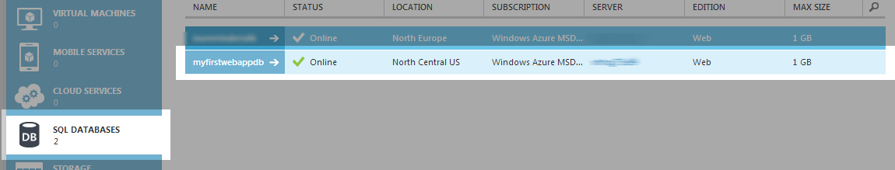

* Step 5: Go to the database dashboard

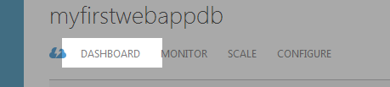

Once on the dashboard you need to ensure that other azure services are allowed to communicate with you database (this should be set by default). If this option is not selected the firewall on the sql azure database will disallow connections from your website:

* Step 6: Select ‘Manage allowed IP addresses’

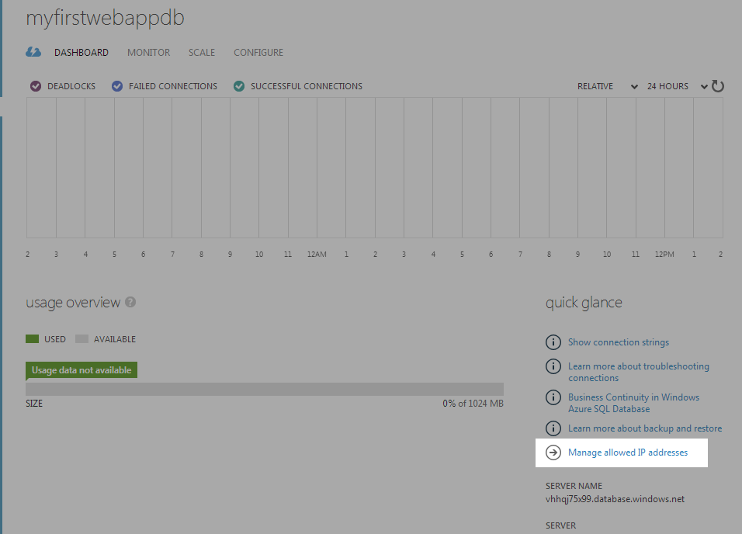

* Step 7: Ensure that ‘Windows Azure Services’ under ‘allowed services’ is set to Yes

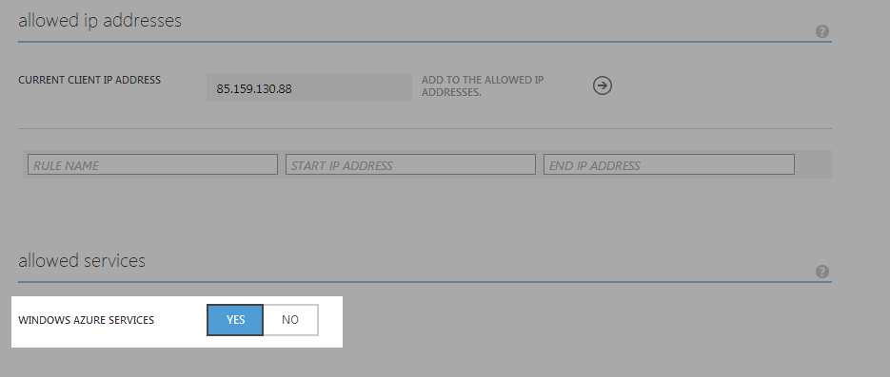

Finally you need to get the connection string for the database:

* Step 8: From the database dashboard (see Figure 6-4), select “Show connection strings”

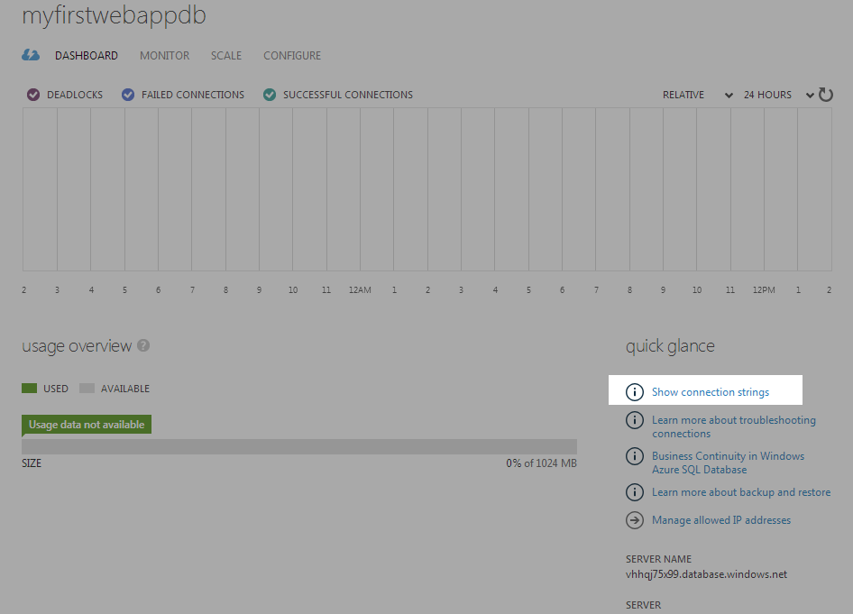

* Step 9: On the window that pops up copy the connection string labelled ‘ADO.NET’ for later use:

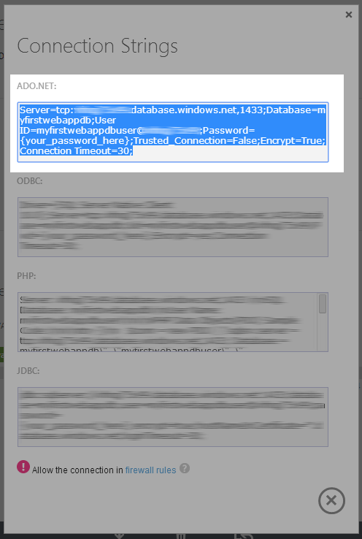

Your database is now set-up and ready for you to configure in your web app.

### Updating Connection Details in Your Web App

The next step is to update you mvc appication to point at the newly created sql azure database.

* Step 1: Within your visual studio project, find the file called Web.config and open it

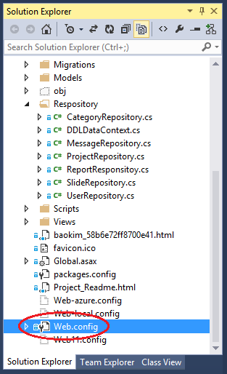

1. M

* Step 2: Add the following code into the file directly.

<connectionStrings>

<add name="DDLDataContext"

connectionString=”*enter your connection string here*”

providerName="System.Data.SqlClient" />

</connectionStrings>

* Step 3: Ensure that you replace ‘enter your connection string here’ with the one copied from sql azure earlier
* Step 4: There should also be a placeholer inside the connection string that read ‘{your_password_here}’ – this should be replaced with the password you set earlier.
* Step 5: Save the file

## Create & Deploying the Azure Website

### Create Azure Website

In order to deploy your website to windows azure you’re going to need to set-up an account. At [Windows Azure website](http://www.codenutz.com/azure) you can create an account for free and have a free trial. Furthermore, at this point in time you can set-up up to 10 azure websites for free – you cannot use custom domain names, ssl or several other features, but they are perfect for experimentation.

Once you have created you account head to [http://manage.windowsazure.com](http://manage.windowsazure.com/) where you can set-up your first website:

* Step 1: From the main screen click the new button in the bottom left corner



1. M

* Step 2: Select **Compute** **🡪 Web Site 🡪 Quick Create.**
* **Step 3:** Enter the name for your website, I used “dandeliondemo” (note that you have to choose a name that’s available).
* Step 4: Select a region where you want your site to be hosted, I suggest choose South East Asia
* Step 5: Press create website

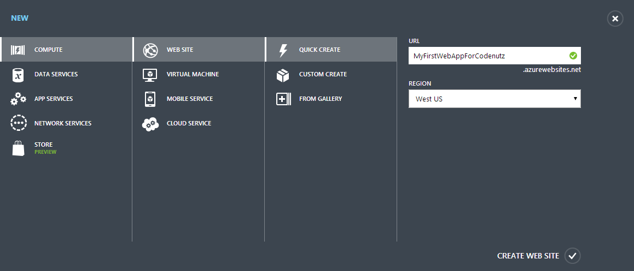

1. M

You’ll have to wait a few seconds for azure to spin up the website, but you will be able to see in the interface a green tick denoting that it is ready to use:



1. M

* Step 6: Once it is ready click on it, and select ‘Download publish profile’ – this should download a file to your computer called something like Dandeliondemo.azurewebsites.net.PublishSetting

Now you’ve got an azure website ready, we can get to publishing your mvc site to the azure service.

### Deploying to the Azure Website

* Step 1: From visual studio, right click the website project and choose the ‘Publish…’ option. You should be presented with a publish dialog like this:

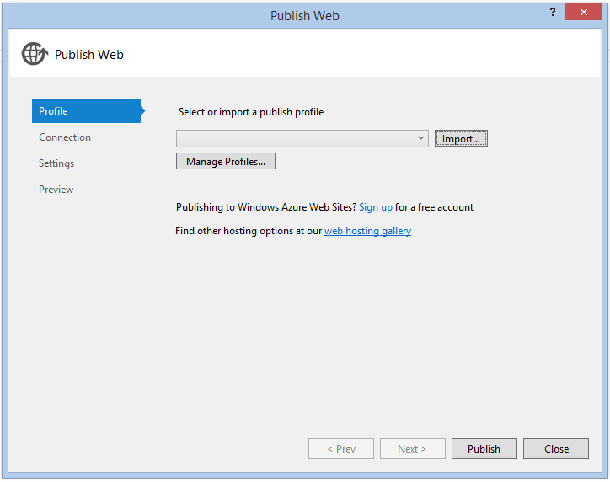

1. M

* Step 2: Choose ‘Import…’ – on this screen you can choose to import the profile directly from azure, or from a profile file. Either is very simple, but as we downloaded this file we’ll choose ‘Import from a publish profile file’. Click the browse button, select the file you just downloaded and click Ok. ***This will prepopulate a number of fields in the publish dialog which for now we dont need to worry about.***
* Step 3: Finally just click the ‘Publish’ button, and you website will be deployed to windows azure. You should see the progress reported from within the visual studio output window with various bits of information like ‘Adding file…’ and ‘Adding ACLs’ etc. The first time you deploy tends to be the longest as all of the files have to be uploaded – subsequent deployments are much quicker as only the changed files are transferred.

Once your website has finished deploying, visual studio should automatically open it in your browser for you, which should look something like this:

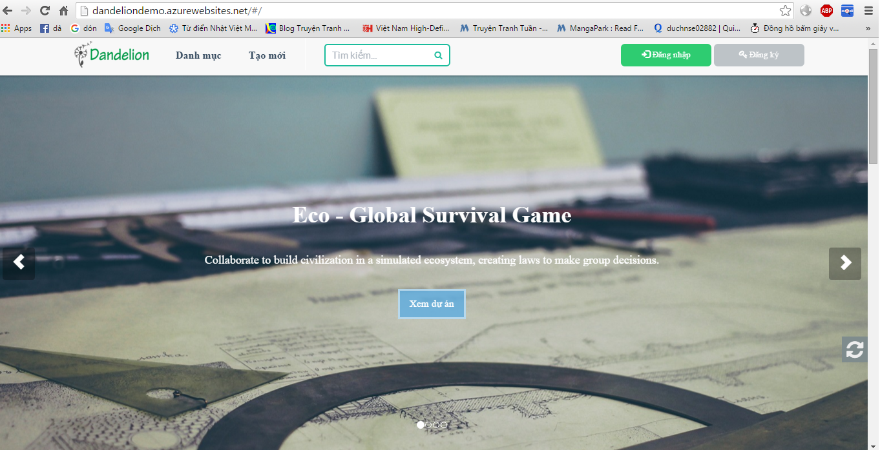

1. Website screen after deploy successfully

## Connecting SQL Management Studio to SQL Azure

### Allowing access to SQL Azure

Here we’re going to set the SQL Azure fierwall to allow connections from our local IP.

* Step 1: Navigate to your SQL Azure database dashboard (more detail instructions can be found in Creating a SQL Azure Database.
* Step 2: Next go to ‘Manage allowed IP addresses’



1. M

* Step 3: You should see on this screen that your IP address is listed as ‘Current client IP Address’. Here Azure has recognised your ip address and listed it for you so that you can easily add it to the firewall rules:

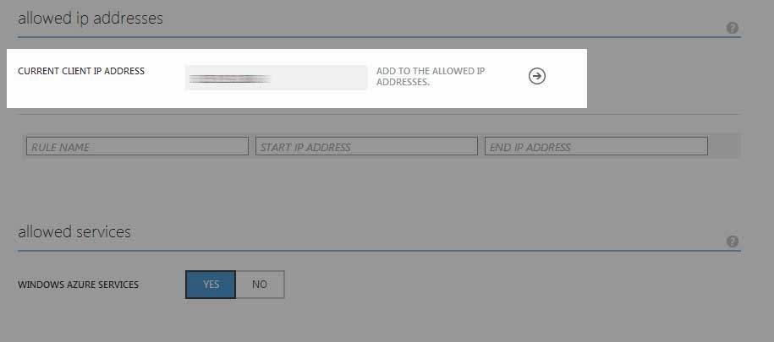

1. N

* Step 4: To add the firewall rule simple click right arrow and you should see the IP address move into the list of rules:

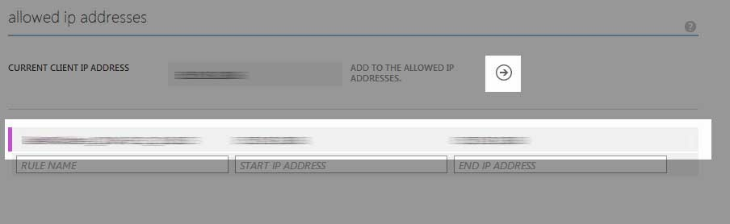

1. M

* Step 5: Finally click the Save button at the bottom of the page

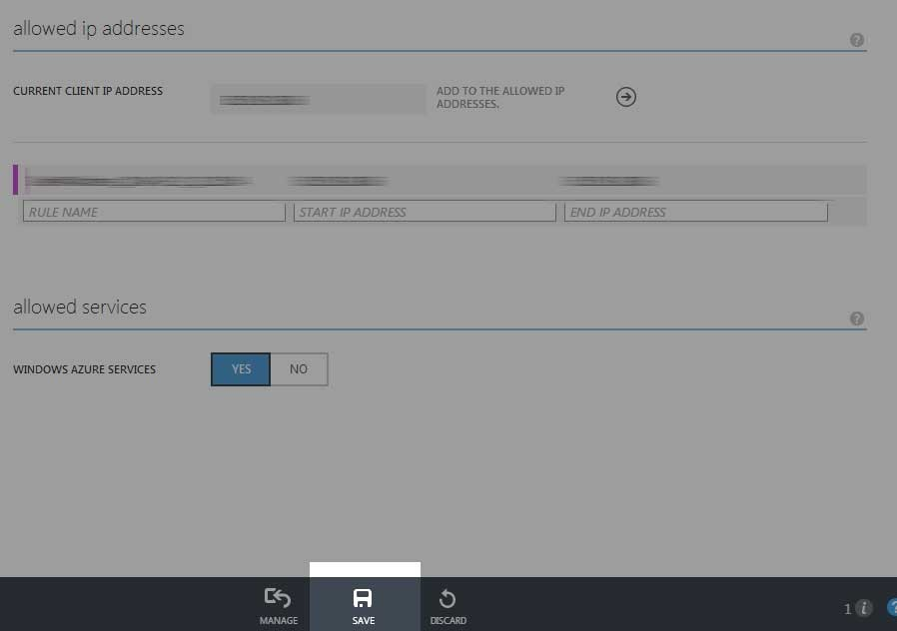

### Connecting with SQL Server Management Studio

To connect to your database you need the full name of the server (servername*.database.windows.net*) that contains the database you want to connect to:

* Step 1: Go to the [Azure Portal](https://portal.azure.com/)
* Step 2: Browse to the database you want to connect to.
* Step 3: Locate the full server name:

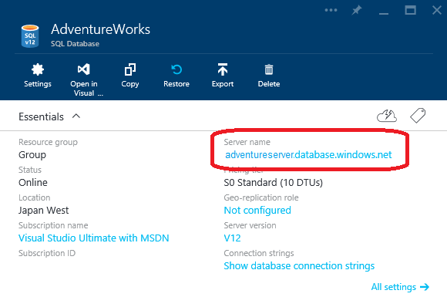

1. M

Use the fully qualified server name in step 3 below to connect to SQL database.

* Step 1: Open SSMS.
* Step 2: Click Connect > Database Engine...

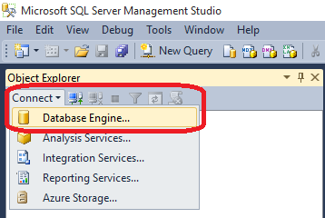

1. M

* Step 3: In the Connect to Server dialog box, in the Server name box, type the server name in the format *<servername>*.database.windows.net.
* Step 4: In the Authentication list, select SQL Server Authentication
* Step 5: Enter the Login and Password you specified when you created your SQL Database server, and click Connect.

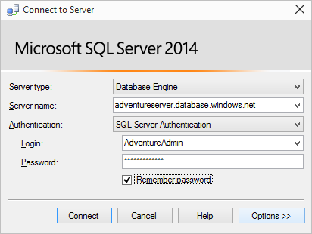

1. M

If the connection fails: Make sure that the firewall of the logical server you have created allows connections from your local computer. For more information, see [How to: Configure Firewall Settings on SQL Database](https://azure.microsoft.com/en-us/documentation/articles/sql-database-configure-firewall-settings/).